Data model diagram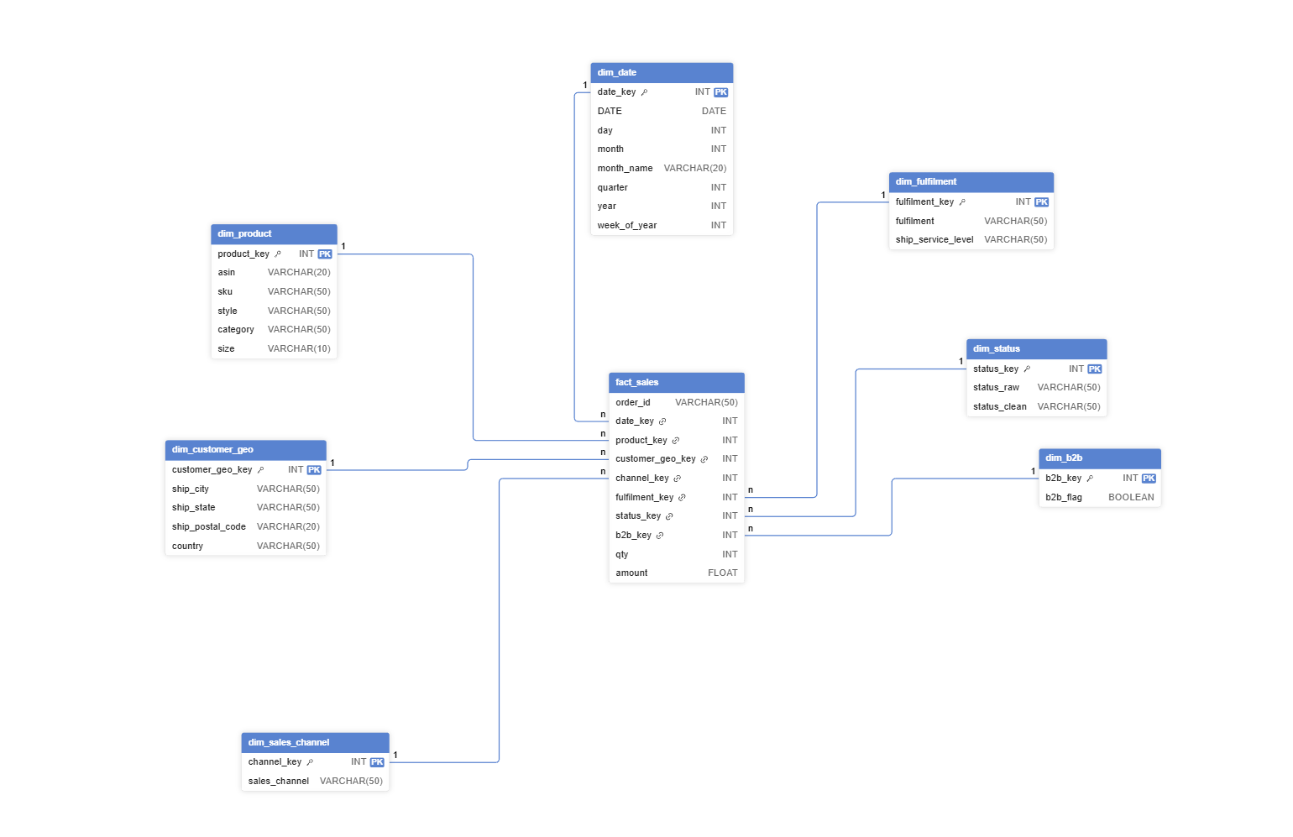

dimensional star schema

Fact Table

Fact_Sales
Contains all numeric, aggregatable fields.
Column
order_id
date_key
product_key
customer_geo_key
channel_key
fulfilment_key
status_key
qty
Amount

DimensionTables

Dim_Date
Column | Description
date_key (PK) | Surrogate key
date | Actual date
day
month
month_name
quarter
year
week_of_year

Dim_Product
Column
product_key (PK)
asin
sku
style
category
size

Dim_Customer_Geo
Column
customer_geo_key (PK)
ship_city
ship_state
ship_postal_code
country (optional)

Dim_Sales_Channel
Column
channel_key (PK)
sales_channel

Dim_Fulfilment
Column
fulfilment_key (PK)
fulfilment
ship_service_level

Dim_Status
Column
status_key (PK)
status_raw
status_clean

Dim_B2B
Column
b2b_key (PK)
b2b_flag

Measures Definition (One-Page BI Sheet)

Core Measures

🧮 Total Sales
SUM(amount)
Description: Total revenue generated.
Total Quantity Sold
SUM(qty)
Description: Total number of units sold.

Total Orders
DISTINCTCOUNT(order_id)
Description: Number of unique customer orders.

Average Order Value (AOV)
SUM(amount) / DISTINCTCOUNT(order_id)
Description: Average revenue per order.

Average Selling Price (ASP)
SUM(amount) / SUM(qty)
Description: Average price per unit sold.

Operational Measures

Cancelled Orders
CALCULATE(
DISTINCTCOUNT(order_id),
status_clean = "Cancelled"
)

Delivered Orders
CALCULATE(
DISTINCTCOUNT(order_id),
status_clean = "Delivered"
)

Delivery Rate %
Delivered Orders / Total Orders

Cancellation Rate %
Cancelled Orders / Total Orders
Time Intelligence Measures

Month-over-Month (MoM) Sales Growth
(Sales - Previous Month Sales) / Previous Month Sales

Year-over-Year (YoY) Sales Growth
(Sales - Last Year Sales) / Last Year Sales

Sales Trend
SUM(amount) by Date

